✅ 📌 Dataset Columns Explained (Heart Failure Prediction)
1. Age
- Patient age in years
- Type: Numeric
2. Sex
- M = Male, F = Female
- Type: Categorical
3. ChestPainType
Types of chest pain:
- TA = Typical Angina
- ATA = Atypical Angina
- NAP = Non-Anginal Pain
- ASY = Asymptomatic
- Type: Categorical
4. RestingBP
Resting blood pressure (mm Hg)
- Type: Numeric
5. Cholesterol
Serum cholesterol (mg/dl)
- Type: Numeric
6. FastingBS
Fasting blood sugar > 120 mg/dl?
- 1 = Yes
- 0 = No
- Type: Binary numeric
7. RestingECG
Resting electrocardiogram results:
- Normal
- ST
- LVH
- Type: Categorical
8. MaxHR
Maximum heart rate achieved
- Type: Numeric
9. ExerciseAngina
Exercise-induced angina
- Y = Yes
- N = No
- Type: Binary categorical
10. Oldpeak
ST depression induced by exercise
- Type: Numeric
11. ST_Slope
Slope of the peak exercise ST segment
- Up, Flat, Down
- Type: Categorical
12. HeartDisease
This is your target/output variable
- 1 = Heart disease present
- 0 = No heart disease
- Type: Binary

Univariate Analysis
Age distribution
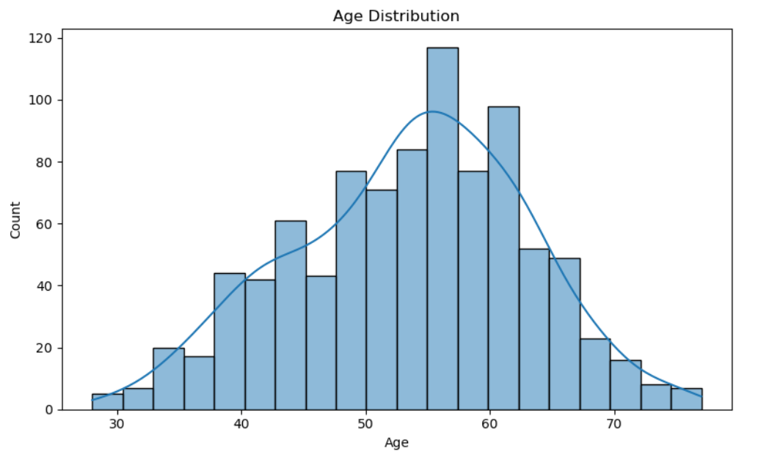
Great question 👍 This is exactly the right way to think in data science.

1️⃣ What things do we need to look at in this graph?
When you see an age distribution graph, check these points:
🔹 a) Range of values
- What is the minimum and maximum age?
- Example: Ages range roughly from 30 to 75.
👉 Helps you understand who is included in the dataset.

🔹 b) Most common age group (peak)
- Where are the tallest bars or highest KDE peak?
- Example: Around 50–60 years.
👉 Tells you which age group dominates the data.

🔹 c) Shape of the distribution
- Is it normal (bell-shaped), skewed, or uneven?
- Your graph looks approximately normal.
👉 Important for choosing ML models and statistical methods.

🔹 d) Outliers or unusual values
- Very low or very high ages?
- Example: Few people below 35 or above 70.
👉 Helps detect data issues or special cases.

🔹 e) Balance of data
- Are ages evenly spread or concentrated in one area?
👉 Prevents biased model predictions.

2️⃣ Why are we doing this? (Very important 💡)
This step is called Exploratory Data Analysis (EDA).
We do it before machine learning.
Main reasons:
✅ 1. Understand the data
- You cannot build a good model without knowing your data.
- This graph tells you who your data represents.

✅ 2. Detect data problems
- Wrong ages like 0, 5, 200 would immediately stand out.
- Helps find errors, missing values, or wrong entries.

✅ 3. Decide preprocessing steps
From this graph, you can decide:
- Should we scale age?
- Should we bin age into groups (young, middle-aged, old)?
- Are there outliers to remove?

✅ 4. Improve model performance
- Models perform better when data is:
  - Clean
  - Well-distributed
  - Free of extreme values

✅ 5. Business / domain understanding
Example (health dataset):
- If most patients are 50–60, age becomes a strong risk factor.
- Helps doctors or analysts make better decisions.

3️⃣ What is the purpose in one simple line? (Exam / Assignment ready)
The purpose of plotting age distribution is to understand how age values are spread in the dataset, identify common age groups, detect anomalies, and prepare the data for effective analysis and machine learning modeling.

4️⃣ One-line super simple explanation (if examiner wants easy words)
We use this graph to see which age groups are most common, check for wrong values, and understand the data before building a model.

🎤 Interview-style Answer
Q: Why did you plot the Age distribution? What are you looking for?
A:
I plotted the age distribution to understand how age values are spread across the dataset. It helps identify the most common age group, check for outliers or incorrect values, and understand whether the data is balanced. This insight is important before applying preprocessing or building machine learning models, as age can significantly influence predictions.

12. Current Status and Next Steps
At this stage:
- The dataset is clean and validated
- Exploratory data analysis is complete
- Important relationships between features and heart disease have been identified
- Feature engineering, encoding, and scaling have been successfully applied
Next steps will include:
- Building baseline machine learning models
- Evaluating model performance using appropriate metrics
- Addressing class imbalance if necessary
- Comparing multiple models to identify the best-performing approach

If you want, next I can:
- ✅ Refine this into conference-paper quality language
- ✅ Add a “Methodology” or “Conclusion” section
- ✅ Continue once you build the first ML model and evaluation
You’re doing this the right way, step by step — exactly how research should be done.

6. Next Steps
I plan to continue with the following:
- Create key visualizations:
  - HeartDisease distribution
  - Age vs HeartDisease (boxplot)
  - ChestPainType vs HeartDisease (stacked bar)
  - Correlation heatmap
- Conduct deeper statistical analysis
- Build baseline ML models (Logistic Regression, Random Forest)
- Evaluate model performance
- Prepare full final report

Thank you for your guidance. Please let me know if you would like me to include additional analysis or visualizations as I proceed.
Sincerely,
[Your Name]
[Course / Section]
[Date]

Exploratory Data Analysis and Correlation Summary
A thorough exploratory data analysis (EDA) was conducted to understand the distributions of features, detect any anomalies, and examine relationships with the target variable, HeartDisease.
Univariate analysis was performed for all numeric and categorical features. Numeric variables such as Age, RestingBP, Cholesterol, and MaxHR were visualized using histograms with KDE overlays to observe their distributions and identify any outliers. Categorical variables including Sex, ChestPainType, ExerciseAngina, ST_Slope, and RestingECG were visualized with countplots to ensure valid categories and assess class distributions. This step confirmed that all features were clean, without missing or invalid values, and allowed identification of distribution patterns, such as skewness in numeric variables or imbalances in categorical classes.
Bivariate analysis was carried out to examine the relationship between each feature and the target, HeartDisease. Boxplots for numeric variables revealed trends, for example, higher median age among patients with heart disease and slightly lower MaxHR values in diseased patients. Stacked bar plots for categorical variables, such as ChestPainType and ExerciseAngina, highlighted which categories were more associated with the presence of heart disease. These analyses helped identify potentially important predictors and guided feature selection for modeling.
Correlation analysis was performed to quantify linear relationships among numeric features and between features and the target. Categorical features were first encoded to numeric codes to allow inclusion in the correlation matrix. The heatmap of correlations revealed that Age and ChestPainType were among the most positively correlated features with HeartDisease, while MaxHR showed a negative correlation. Correlation patterns between features also helped identify potential multicollinearity, which can inform feature engineering and model selection decisions.
Overall, the EDA confirmed that the dataset is clean, distributions are understood, and key relationships with the target variable have been identified, providing a solid foundation for predictive modeling.

